Assignment1.1: Linux Commands with example

a.pwd
pwd command writes the full pathname of the current working directory to the standard output.
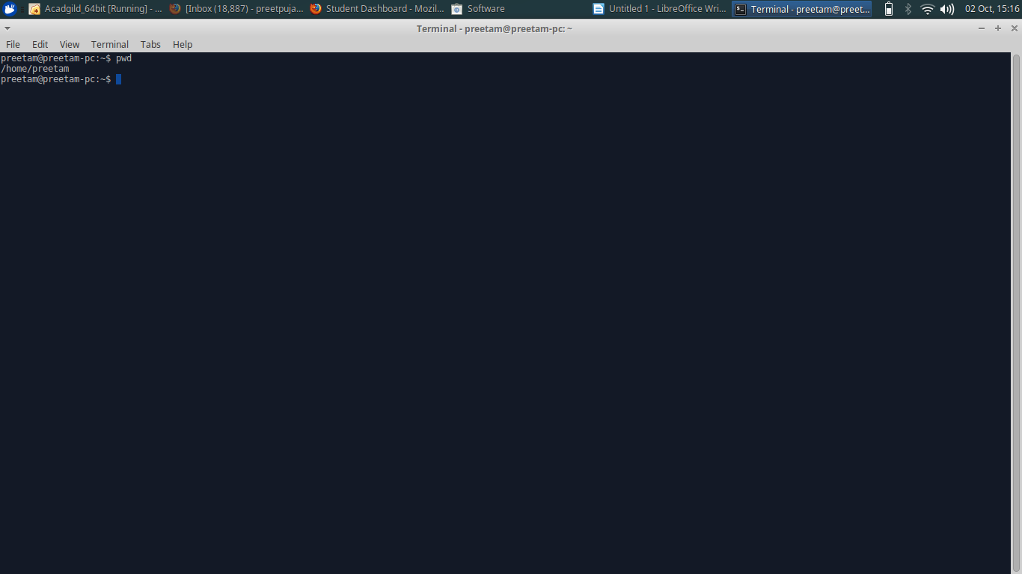

b.vi
vi command opens screen-oriented text editor
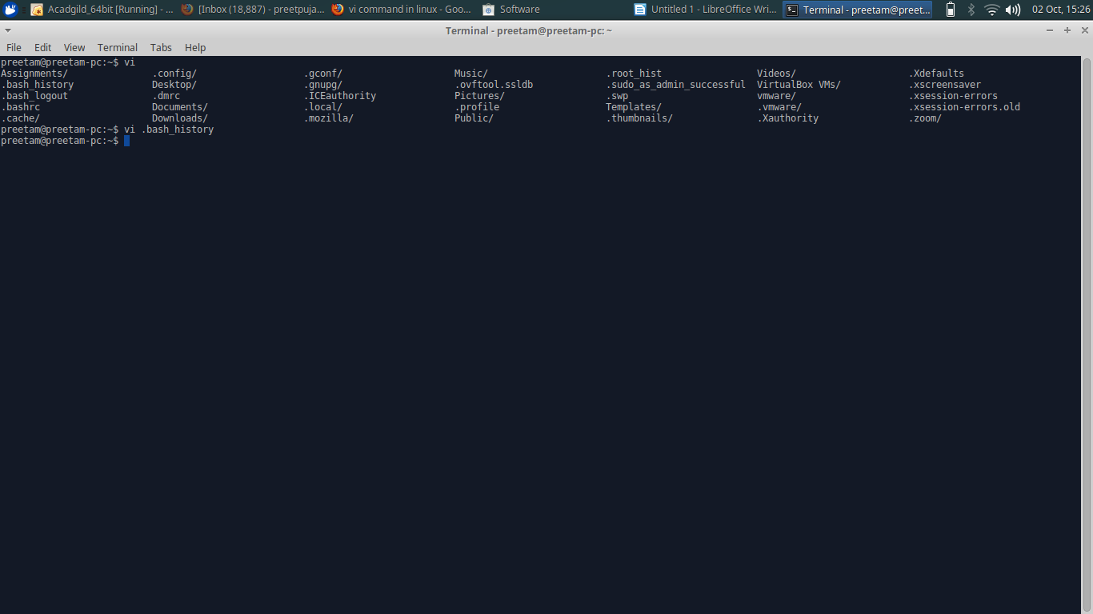
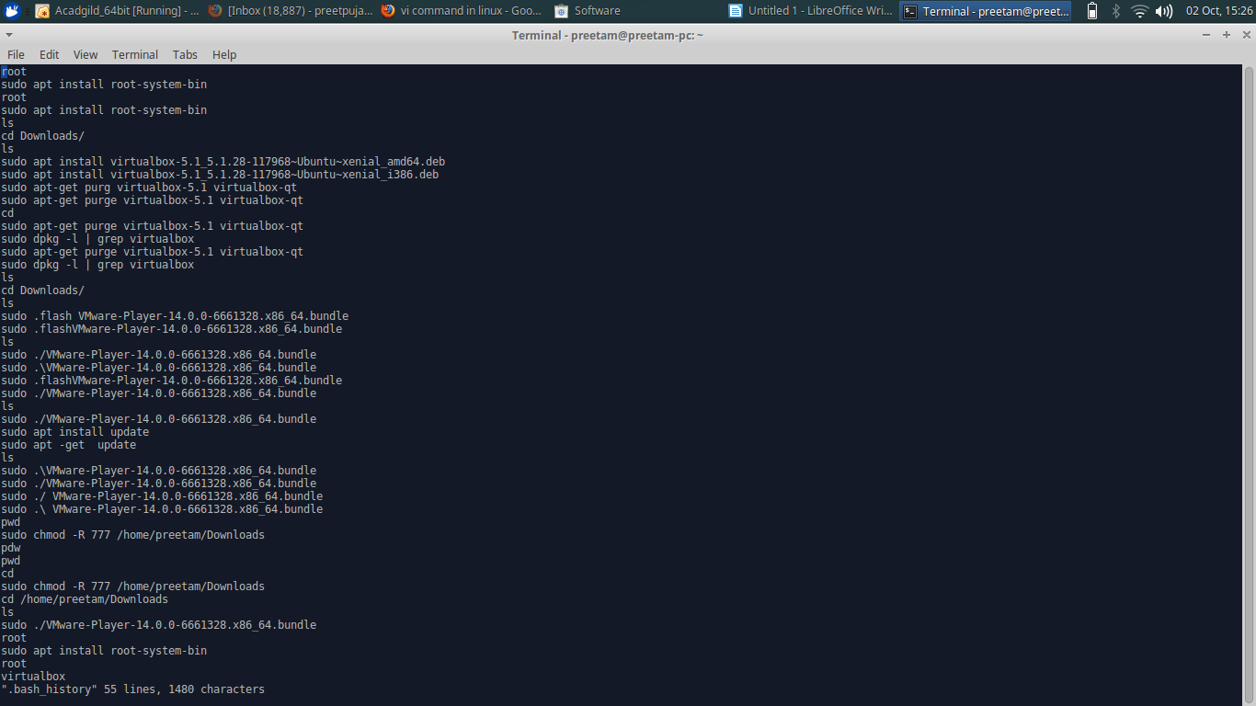

c.touch
touch is a standard Unix program used to change a file’s access and modification timestamps. It is also used to create a new empty file.

The following touch command creates an empty (zero byte) new file called abc.
$ touch abc

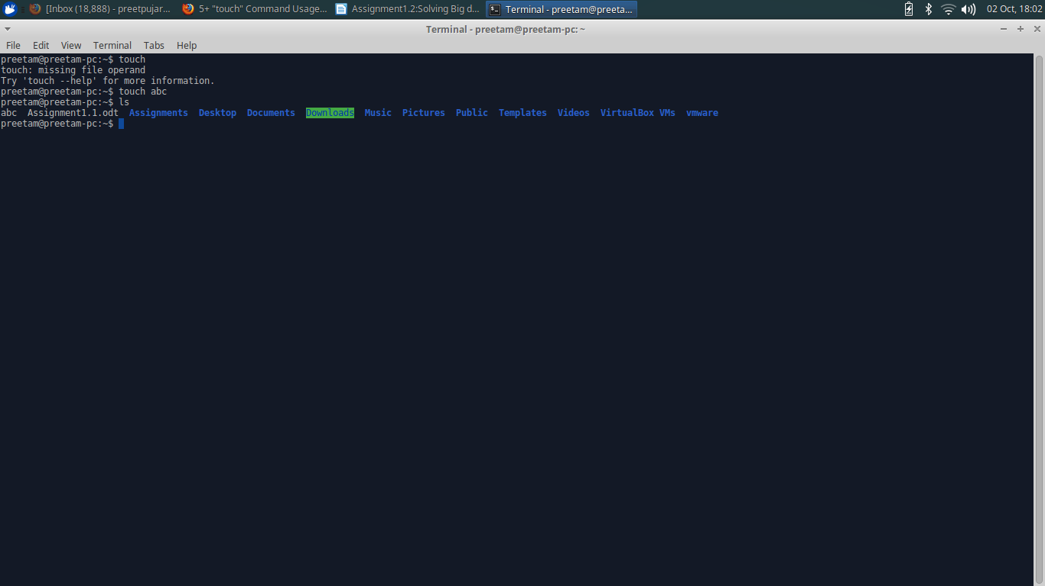

d.mkdir
mkdir command in linux is used to make a new directory.
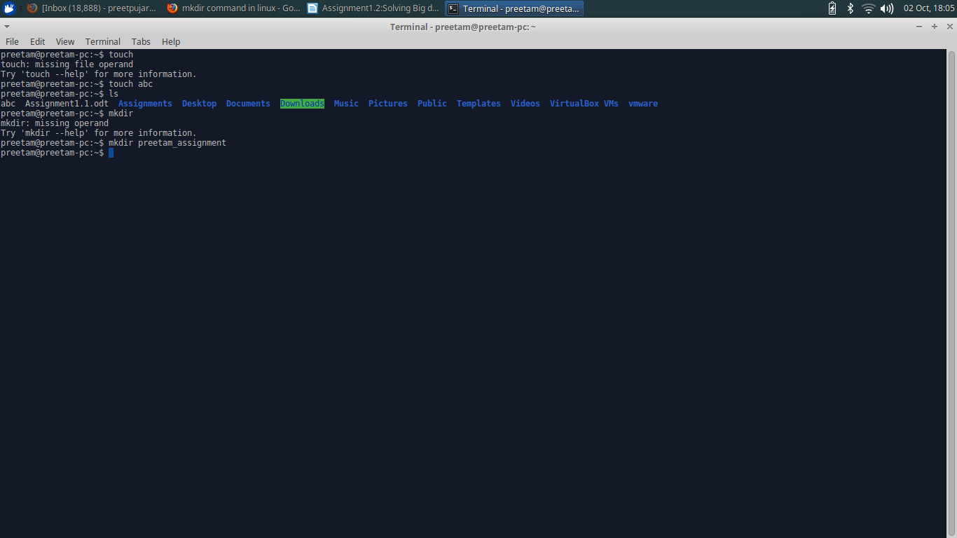

e.rm
rm is a basic UNIX command used to remove objects such as files, directories, device nodes, symbolic links, and so on from the filesystem.

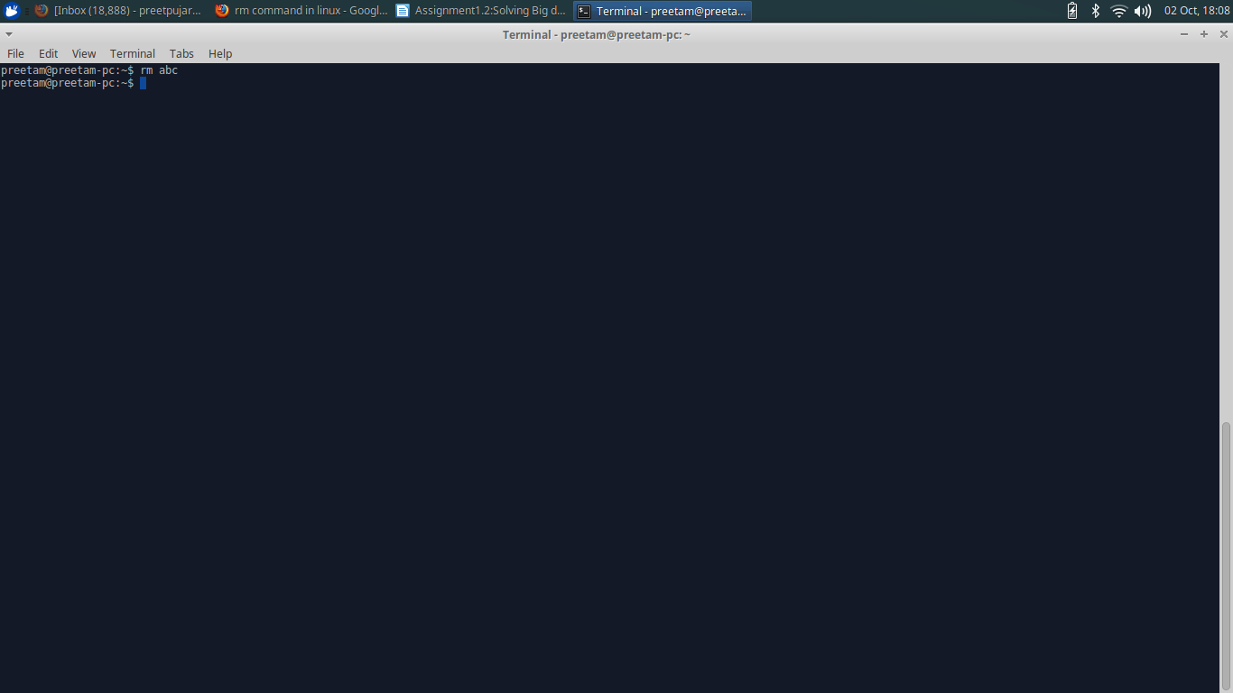

f.ls
It is a command to list files in Unix and Unix-like operating systems.
It lists the files in the current working directory.

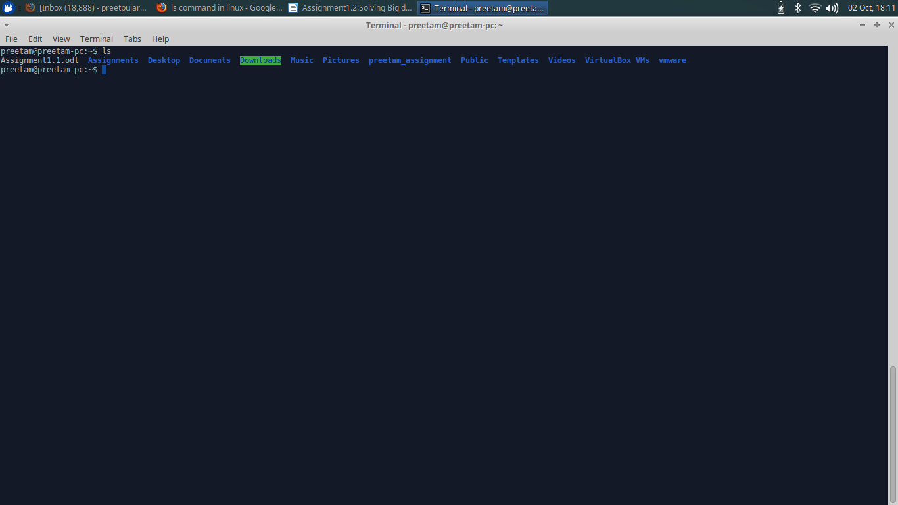

g.echo
echo command outputs the strings.
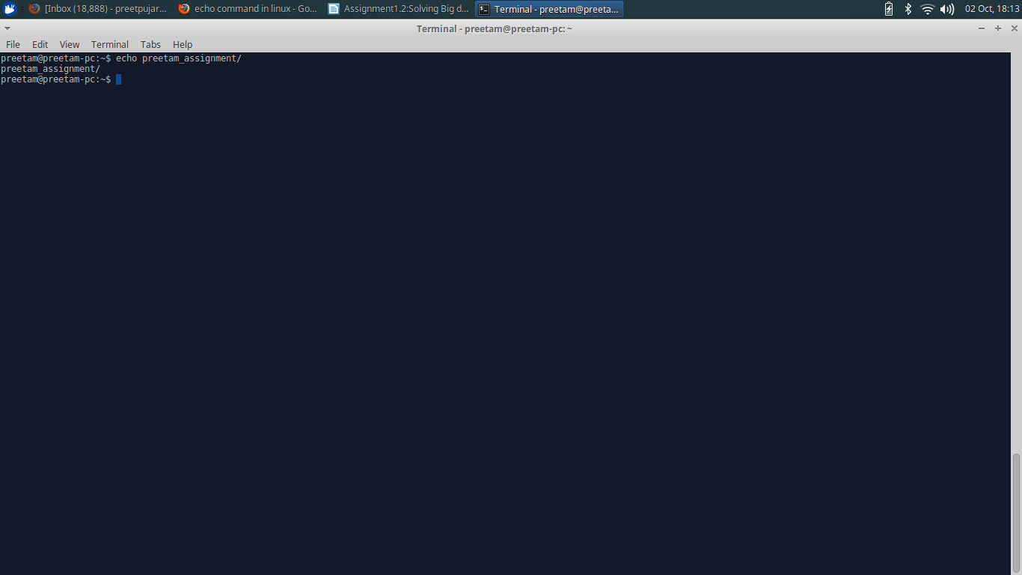

g.cat
cat is a standard Unix utility that reads files sequentially, writing them to standard output.
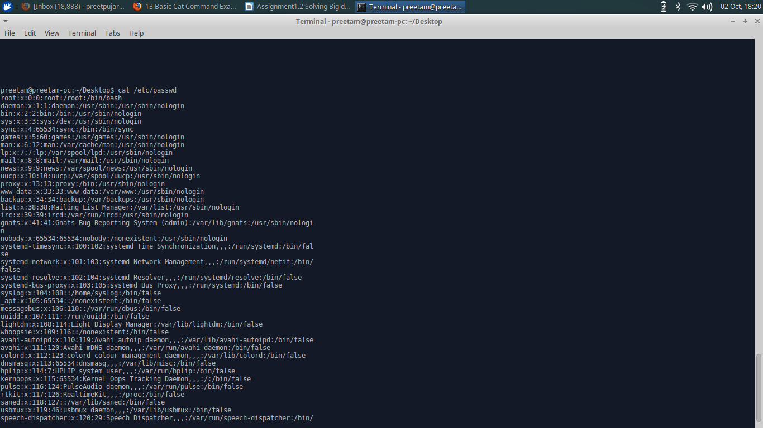

h.who
The standard Unix command who displays a list of users who are currently logged into the computer.
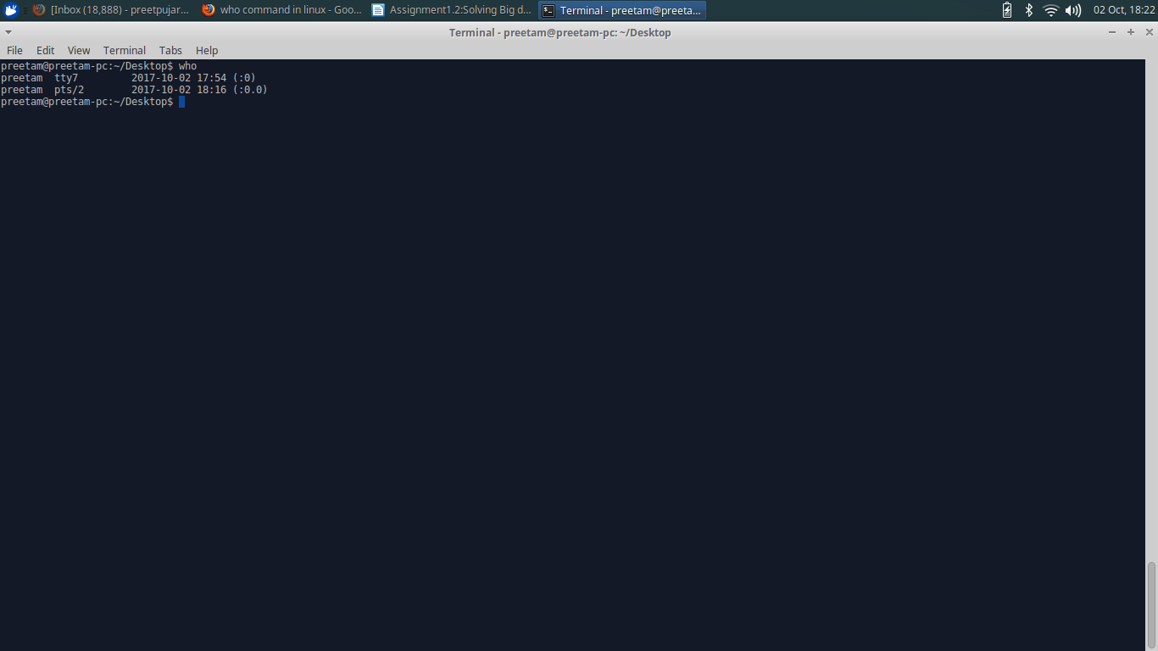

i.cd
The cd command is a command-line OS shell command used to change the current working directory.
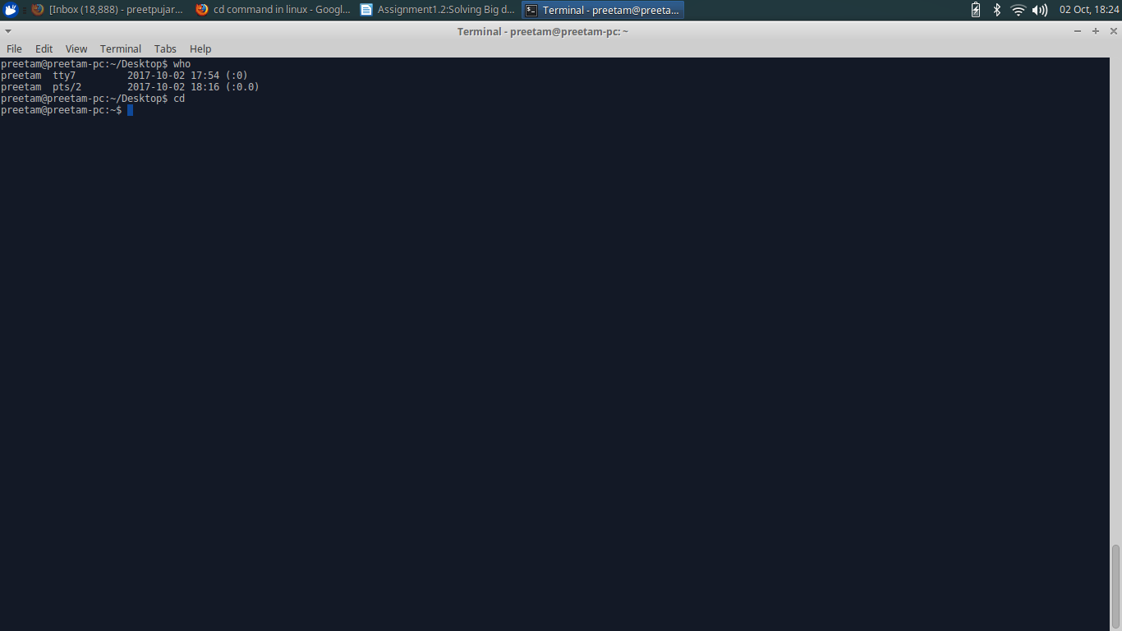

j.date
Date command is helpful to display date in several formats. It also allows user to set systems date and time.

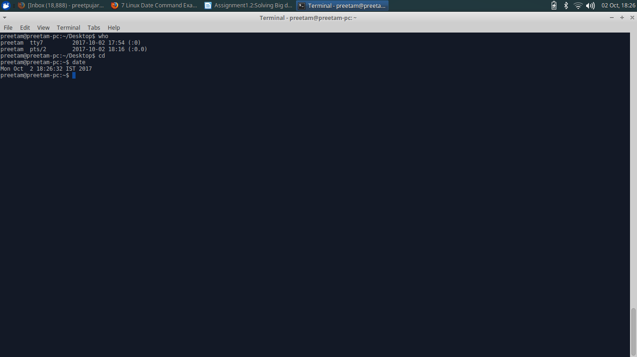

k.cal
cal is a standard program on Unix and Unix-like operating systems that prints an ASCII calendar of the given month or year. If the user does not specify any command-line options, cal will print a calendar of the current month.

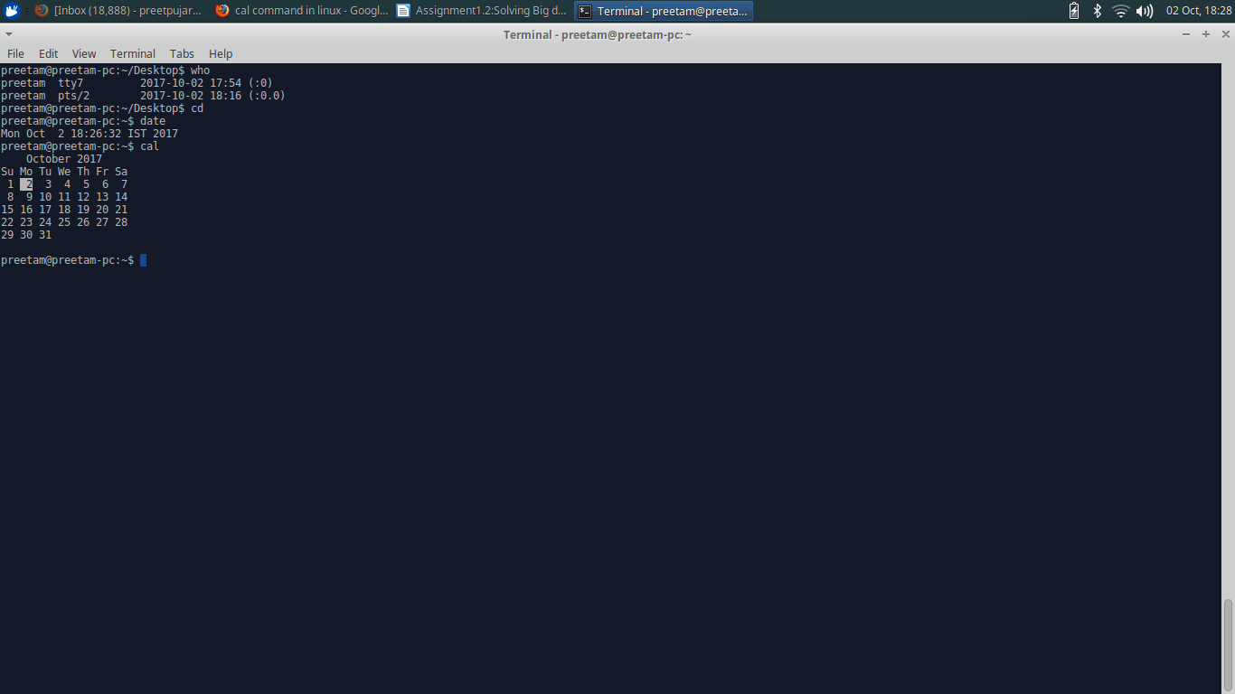

l.mv
mv is a unix command that moves one or more files or directories from one place to another. If both filenames are on the same filesystem, this results in a simple file rename; otherwise the file content is copied to the new location and the old file is removed.

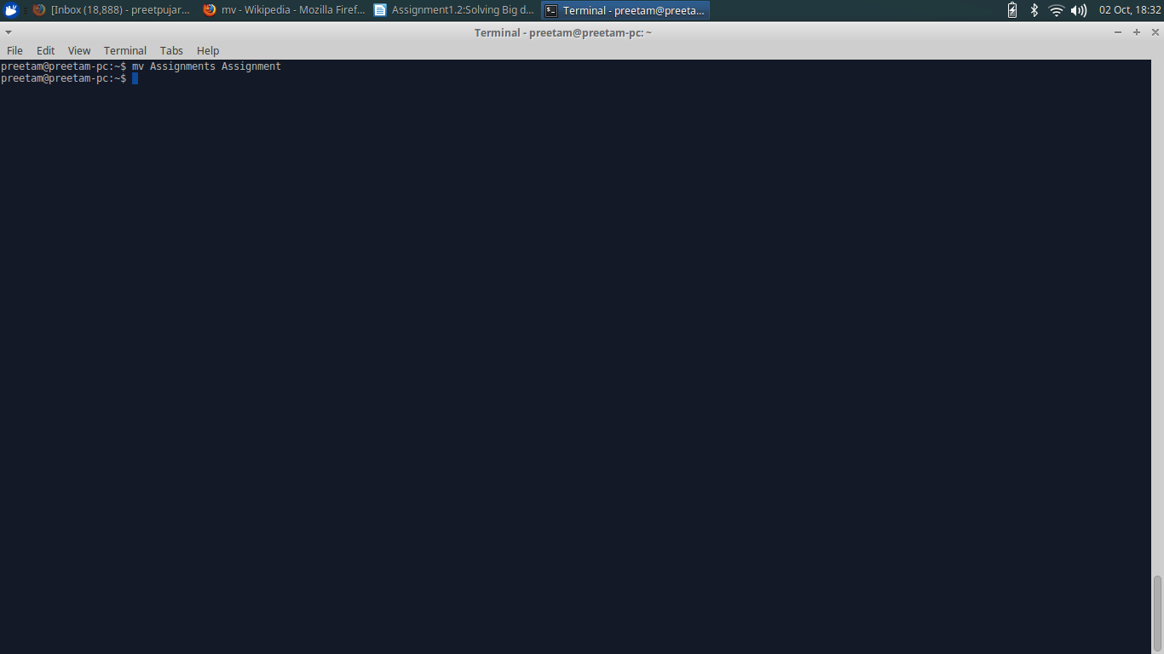

m.cp
cp is a UNIX command for copying files and directories.
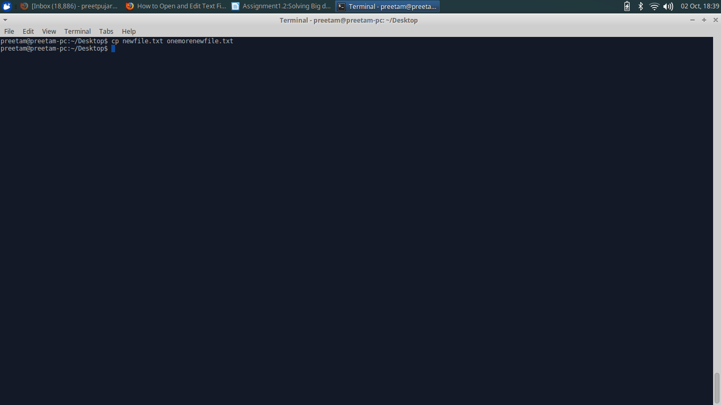

n.which
which is a Unix command used to identify the location of executables.

